|  |
| --- |
| Circle Language Spec: System Objects |

## System Command Extension

One thing that makes it important to be aware of system commands at all is *extension* of system commands.

A system command, such as Value Get, can be decorated with a procedure, that determines the value that is returned. It is the new computer language’s equivalent of Getters and Setters or Property procedures. The Object Get command can be extended as well, which makes you able to further control the connection between one object and the other.

Any system command can be decorated with a Pre‑Extension, Post‑Extension or Override.

System command extensions are implemented the same way as ‘normal’ command extensions. Command extension is put under the topic of *Inheritance*, because it is an extension technique.

System command extension will get a notation, that complies to the notation of normal command extension. The code base will implement system command extension like normal command extension and the way extension is implemented inside the code base will influence how the eventual notation will look.

It might look something like this:

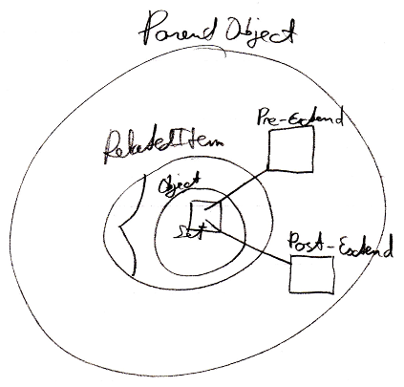

But the exact way in which command extension is implemented will be covered by the *Inheritance* articles.